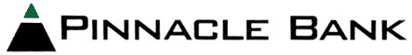

PINNACLE BANCSHARES, INC.
1811 SECOND AVENUE
JASPER, AL 35501
(205) 221-4111

CONTACT: JOE ADAMS, III, CFO
(205) 221-8866

PINNACLE BANCSHARES DECLARES $0.27 PER SHARE

QUARTERLY CASH DIVIDEND

Jasper, Alabama, November 27, 2024 (BUSINESS WIRE) -- Pinnacle Bancshares, Inc. (OTCBB: PCLB) today announced that its Board of Directors has approved a quarterly cash dividend of $0.27 per share. The dividend is payable December 20, 2024 to stockholders of record on December 10, 2024. The quarterly amount is equivalent to an annualized rate of $1.08 per share.

- ##### -

